Parallel explorations: Workshops about and within the Jewish community

Wendy Kalman wkalman@students.kennesaw.edu, MPA & MA in Integrated Global Communications (expected 2022), Kennesaw State University

Pair of workshops: (1) On antisemitism, racism, biases; (2) On biases within the Jewish community, i.e., ridding spaces of Ashkenormativity. Both share some content, that is both workshops will use steps 1 and 4 below. The first workshop is fleshed out. The second, which is not related to ISGAP’s program, is not.

- Where are Jews? (10 minutes):
- World distribution of Jewish population to demonstrate both how small a population we are and how spread out in far more places than commonly thought: www.jewishdatabank.org/
content/upload/bjdb/2018-World_Jewish_Population_(AJYB,_DellaPergola)_DB_Final.pdf
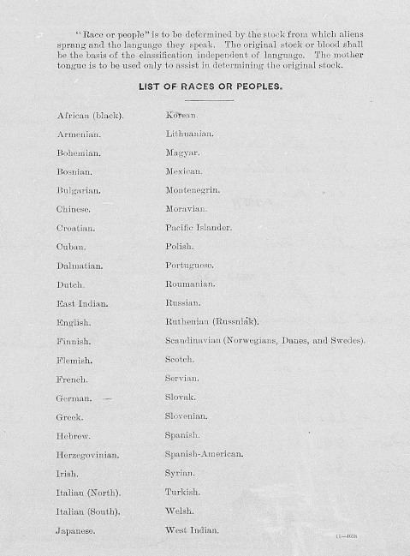
- Migrations, expulsions, exoduses and how that translates into not having a home. History video, 750 BCE until 1917 offers a picture 8:30 minutes: https://www.youtube.com/watch?v=KR9sWRzbdJw
- Antisemitism, racism and other biases portion (25 minutes):
- What is it to be Jewish? Religion vs nation. Religion and nation. Even recognized by the US at one point, e.g., from 1913 manifest of immigrant ships, at right.
- What do you know about Jewish people? How did you get this picture of them?
- Antisemitic tropes through the years. Like racist or homophobic slurs, it is essential to be familiar with them. Sample (watch How Cartoons Brainwashed Us With Jewish Stereotypes www.youtube.com/watch?
v=4df3aD8ZfVw (3 minutes), but also refer to https://antisemitism.adl.org/?_
ga=2.246291149.839499532.1598910273-1268403388.1596763700)
- What other groups have you formed opinions of and how many of those are not rooted in actual experience?
- Have we given thought to what it means for people to face different obstacles in their lives because of how they look, who they love, what religion they belong to? Watch What is Privilege? https://www.youtube.com/watch?v=hD5f8GuNuGQ (4 minutes)
- Have You Ever…? Exercise (pen and paper to keep answers private). Source: ADL/USC Shoah Foundation Institute, USC (http://sfi.usc.edu/sites/default/files/lessons/units/POH_Final_0.pdf)
  - Overheard a joke that made fun of a person of a different ethnic background, race, religion, gender or sexual orientation?
  - Been the target of name calling because of your ethnic group, race, religion, gender, or sexual orientation?
  - Made fun of someone different from you?
  - Left someone out of an activity because he/she was different from you?
  - Not been invited to attend an activity or social function because many of the people there were different from you?
  - Engaged in stereotyping (lumping together all people of a particular race, religion, or sexual orientation? Ex: White men can’t jump!)
  - Been threatened by someone who is different from you because of your difference?
  - Committed an act of violence against someone because that person was different from you?.
- Instead of focusing on differences, how do we find commonality? (10 minutes)
- Watch All that we share video (3 minutes): https://www.youtube.com/watch?v=jD8tjhVO1Tc
- What is the consequence of defining people by as single facet of who they are, whether it is accurate or hateful? (refer to The Danger of a Single Story for home viewing: https://www.ted.com/talks/chimamanda_ngozi_adichie_the_danger_of_a_single_story)
- End note: How do we get rid of these pictures in our heads? If we cannot replace via first person interaction, then we need education and exposure. Commit to reading, watching, doing.

