Collin College

History Seminar: Minding Historical Gaps

Dr. John P. Williams

“If you want to walk fast, walk alone. If you want to walk far, go with others.”
(African Proverb)

Seminar Rationale:
The study of introductory-level United States history in American colleges and universities is divided traditionally into two survey courses with “U.S. History I” covering the Pre-Columbian Era through the Civil War and “U.S. History II” covering the Reconstruction period to the present day. Combined, the two surveys encompass over 3,000 years. One of the most important aspects of this organizational structure is an emphasis upon overlapping themes, concepts, and paradigms running through both courses. This approach not only has breadth and depth, but also highlights and explains the historical context underlying many relevant topics of importance to Americans today.
However, a prime inadequacy within the current design of most survey courses is the omission of the theme of antisemitism. Proper attention given to the study of historical antisemitism and its impact on current social, economic, and political problems in the United States, and indeed the world, would illuminate the endemic contemporary social problems of racism, sexism, Islamophobia, and xenophobia. By examining both historical and present-day antisemitism, professors teaching American history survey courses could fill in these important historical gaps of knowledge to provide a more complete understanding of United States history that would also be directly relevant to important modern social issues.
Major gaps regarding historical antisemitism currently exist in the teaching of United States history. A survey with five questions related to the teaching of these two subjects in conjunction with one another was given to over 50 university and community college professors. The results of this survey are alarming: Even though there were at least 10 specific historical events (see appendix A) that should be covered in U.S. History I and in conjunction with U.S. History II that directly contribute to the rise of the Nazi agenda and the Holocaust, instructors according to the survey did not teach them at all since they deemed these topics not relevant or received little or no attention (see Appendix B). In other words, students will cover 20 chapters in their American history class before being presented with material related to antisemitism and its correlation to racism. To ignore this hateful, racist aspect of United States history for so long is a moral oversight in the design of the current curriculum. We would be leveraging our introductory survey history classes to help our students better understand and appreciate answers to such questions as, why do people hate? Is hate historically conditioned? What allows hate to become universally accepted? What happens when people ignore the proliferation of hate towards a minority group to the point that it becomes accepted by mainstream political thinkers?
Seminar Overview:
Recent events in the United States and throughout the world have brought to the forefront issues related to antisemitism, Islamophobia, racism, sexism, and xenophobia. For example, antisemitism and racism in the United States and in Europe is up over 70% in the last three years, and the rise of Islamophobia in parts of Russia, China, and Africa is also rising as well. However catastrophic, deadly, and destructive these issues and events have become, they can serve as “teachable moments,” calling for instructors to use the humanities, namely history, to help their students better understand current events and their outcomes in both an objective and subjective manner.
This seminar project “MINDING HISTORICAL GAPS” has been created in response to this crisis: to help instructors use historical facts to enable students to better understand and interpret current events. To aid in this effort, this seminar draws upon the study of historical antisemitism and its associated tropes, motifs, and diatribes to relate them to key events, political and social ideologies, and movements, as they relate to American history. Through the study of antisemitism, instructors will illustrate the themes of racism, xenophobia, and sexism in human history.
It is important to note that antisemitism is considered by many historians and scholars to be not only unique (it is enduring, it is intense, and it is universal), but it also serves as a template for the “original hate” -- an ideology of intolerance that was, and still is, directed at one group for its distinct origins, beliefs, mores, and values. These very same attributes make Jews and antisemitism the perfect study for a better understanding of racism, xenophobia, and Islamophobia and all its tropes, diatribes, and motifs.
This seminar will examine the phenomenon of antisemitism through its various stages of historical development with an emphasis on two primary themes: (1) the intellectual, religious, political, and social roots of Jew-hatred, and (2) the impact of antisemitism on Jewish life and culture in Europe and later in America. This survey of antisemitism and its impact will begin with the ancient period (Egypt), continue to the late nineteenth century, and will conclude with the roots of modern genocide, the Holocaust, and contemporary antisemitism. Topics include pagan responses to Jews, Christian theological antisemitism, the first Crusade, the ritual murder accusation, the blood libel, the Inquisition, the impact of the Reformation, Russian pogroms, antisemitism in America, the Holocaust, Holocaust denial, and Arabic antisemitism.
Seminar Learning Objectives:
- To better understand and appreciate how historical antisemitism interacts with past and contemporary events in the United States and in Europe;
- To appreciate the effect Jewish history has on American and European history, and the role (unwillingly foisted upon them) of victim, whose persecution has helped define modern racism, antisemitism, stereotypes, biases, and ethnic discrimination;
- To understand the connections between antisemitism in Europe and Middle Eastern histories and relate them to United States history;
- To consider the presence and effects of antisemitism in educational institutions;
- To cultivate a critical understanding of antisemitism as reflected through film, television, and song;
- To promote systematic observations, discussion and reflection among attendees concerning prejudice and antisemitism in their teaching of US History I and II.
Seminar Requirements:
- Attendees are required to attend all seminar sessions, and to complete all reading assignments online or in print.
- Attendees are to demonstrate a command of assigned readings, the ability to engage in meaningful discussion with other students and the professor, and present an oral presentation based on topics related to antisemitism in an assigned contemporary setting.
- Attendees are expected to respect and appreciate the breadth and depth of this seminar and use the reading, discussions, and final project to enhance their own teachings of American history and topics related to antisemitism.
- Attendees are required to submit an end-of-course summary essay that encompasses major themes, concepts, and arguments covered in each of the five sessions. This essay will be at least 6,000 words in length using proper citations (Chicago Style). It is due 14 days following the conclusion of this seminar to the Division Office.
Seminar Materials:
- Each seminar attendee will receive a printed copy of all articles and a copy of all books used for this seminar.
- All films discussed in this seminar are located in the Collin College library and can also be accessed through the online portal for streaming.
- All attendees will be given Collin College service hours credit for attending this seminar.
Seminar Attendees:
The seminar selection committee will select from a pool of candidates 6 full-time faculty, 6 adjunct faculty and 3 emerging young scholars from the Collin College student body. The seminar is free to all seminar attendees. All materials for this seminar are provided and college service hours applied.
Course Schedule:
This seminar is broken into (5) two-hour sessions. Each session will consist of three parts: lecture, film, and discussion. Should any attendee have to miss a session, they are to notify the Collin College division office as soon as possible so that materials covered can be disseminated. All sessions will be recorded.

Session One:
Topics related to this first session include the following:
- What is Jew hatred? What are its origins?
- What is antisemitism? What are its main elements and features?
- What is a diaspora? Which groups historically lay claim to diaspora status?
- What makes antisemitism unique and worthy of study as a lens to view and examine
other forms of hatred?
- What past events from antiquity to the present help us better understand antisemitism and its relationship to current events?
- What pall did the destruction of the first and second Temple cast on Jews?

Readings:
“Antisemitism: How the Origins of History’s oldest Hatred still hold sway today” Gervase
Phillips, The Conversation, February 27, 2018. https://theconversation.com/antisemitism-how-the-origins-of-historys-oldest-hatred-still-hold-sway-today-87878.
Prager, Dennis (2003), “Why is Jew Hatred Unique?” 2-32.
“The Rumour About the Jews,” Francesca Trivellato, Aeon,
https://aeon.co/essays/what-is-the-link-between-medieval-and-modern-antisemitism
Westrich, Richard (1991), The Longest Hatred, p. 1-30.

Film:
- “Hatred of Jews is Unique, Says Dennis Prager” at Proclaim 18
Link: https://www.youtube.com/watch?v=lJv7_0j3xeA
- Corey Gil-Shuster, “Israelis: Is being Jewish a religion, a nationality or both?” https://www.youtube.com/watch?v=Yul533vTqQk
DQs:
- In your own educational experience, were you taught the origins of Jew hatred or antisemitism? If so, what was the timing and context of its teaching?
- Why does the discussion of antisemitism not come up more in American history survey courses given its longevity and impact throughout human history?
- Why do American students consistently demonstrate historical gaps in their learning regarding history and some of the tropes, motifs, and diatribes already discussed?
- How has your personal experience with learning about antisemitism impacted your teaching and world view?

Session Two:
Topics related to this second session include the following:

- What is a trope? Diatribe? Motif? What is their relationship to propaganda? Racism?
- How is each used to maintain or attack the status quo?
- What are some examples that have been used to facilitate antisemitism?
- What role did the Christian church play in the perpetuation of antisemitism?
- What does Shakespeare and Chaucer have to do with it?
- When did antisemitism go secular? What does science have to do with it?

Readings:
- Frank, Steve. “’The Merchant of Venice’ perpetuates vile stereotypes of Jews. So why do we still produce it? Let us give this Shakespeare play a rest from the stage.” Washington Post, July 28, 2016.
- Chazan, Robert. “Why Medieval Art is So Unflattering to Jews”, April 2, 2015, The Snooze, https://forward.com/schmooze/218198/why-medieval-art-is-so-unflattering-to-jews/
- “Antisemitism in the Era of Nationalism: When did Antisemitism Go Secular?” https://encyclopedia.ushmm.org/content/en/article/antisemitism-in-history-the-era-of-nationalism-1800-1918
- “The Jews and Their Lies.” Martin Luther (1543) Translated by Martin H. Bertram
- Anti-Semitism in Chaucer’s “Prioress’s Tale” by Emmy Stark Zitter
- Laqueur, Walter (2006) The Changing Face of Antisemitism, p. 1-63.
- Gerber, Mark H. “What Is Literary Antisemitism?” Jewish Social Studies, pp. 1-20. DOI: 10.2307/4467277 https://www.jstor.com/stable/4467277

Film:
- David Lawrence Young, “The Jew in English Literature,”
https://www.youtube.com/watch?time_continue=1&v=w-iPCKu5YHw&feature=emb_logo
- “Coursework: Anti-Semitism in Germany 1819-1945- Violence, Media, and Literature,”
https://www.youtube.com/watch?time_continue=16&v=_GK_5gXCQ10&feature=emb_logo

DQs:
- Think back to your own education. At what point, if ever, was antisemitism brought up in connection with Shakespeare’s or Chaucer’s work?
- How much have you heard, prior to reading the assigned selection, about Martin Luther’s opinion on Jews? Why do you think this has been your experience? How would you compare your experience to the average college student?
- What other examples in literature can you think of that bring out antisemitism, xenophobia, racism, and sexism?

Session Three:
Topics related to this third session include the following:
- What are the origins of antisemitism in America? What makes it different from European antisemitism?
- Why is antisemitism tolerated?
- Who is Leo Frank?
- What are the origins of antisemitism on college campuses?
- What was the American response to the Holocaust?
- What is the significance of 1948 as a response to the Holocaust and modern Jewish history as well as American history?

Readings:
- Prager, Dennis (2003) “Why the Jews?” pp. 35-90.
- Tibi, B (2017) Antisemitism Before and After the Holocaust.
- Lang. B, Race and Racism in Theory and Practice.
- Banton, M (1998) Racial Theories.
- Montagu, A (1964, 1965) The Idea of Race.
- Wyman, David (1985) Abandonment of the Jews: America and the Holocaust (1941-1945).

Film:
- LINK: https://www.c-span.org/video/?423891-1/jewish-american-history-antisemitism
- “The Holocaust was a Hoax,” http: www.youtube.com/watch?v=3x2UMh9Hr0

DQ:
- What did you think the first time you heard someone refer to the belief that the Holocaust was a hoax? Did other conspiracy theories regarding other historical events being a hoax resonate with you? How did you handle correcting the historical record?
- What is the relationship between Holocaust denial and other forms of historical denials in American history?
- How does this relate to the Black Lives Matter movement? What connections, if any, can you make between Holocaust deniers and Racism deniers? Why?

Session Four:
Topics related to this fourth session include the following:
- What are the origins of Blacks and Jews relation with regards to Civil Rights?
- What is the BLM movement?
- What is the #metoo movement?
- How does the current immigrant crisis draw parallels to historical antisemitism?

Readings:
- “Anti-Semitism in schools in ‘the West.’” http://www.pmw.org.il/BookReport_Eng.pdf
- Romeyn, Esther. http://jcpa.org/article/anti-semitism-and-anti-israelism-in-western-schools/
- Budapest. Rubin, Dan Ian. “Still Wandering: The Exclusion of Jews From Issues of Social Justice and Multicultural Thought.” Multicultural Perspectives. Vol. 15 Issue 4, (Oct 2013), p213-219.
- Charles Asher Small, Global Antisemitism: A Crisis of Modernity (New York, 2014).
- Alexander Tsesis, “Dignity and Speech: The Regulation of Hate Speech in a Democracy,” Wake Forest Law Review, 2009 https://freebeacon.com/issues/anti-semitism-soars-u-s-college-campuses/
- James Baldwin, “A Talk to Teachers” – Delivered October 16, 1963 as “The Negro Child – His Self-image” (originally published in The Saturday Review, December 21, 1963, reprinted in The Price of the Ticket, Collected Non-Fiction 1948-1985, Saint Martins, 1985)
Film:
- Khan, Saffiyah. “Be active, not an activist,” TEDTalk, http://www.youtube.com/watch?v=lpAwk7b4Uqc

DQs:
- In what ways could instructors channel the positive energy of the BLM, #metoo movement, and other civil engagements by young people constructively on campus?
- How much is too much? How much is too little?
- Using the historical record, what events in American history serve as an example to be studied? Discussed? Ignored?

Session Five:
Topics and discussion questions related to this fifth session include the following:
- Is anti-Zionism merely a modern expression of antisemitism?
- Is anti-Zionism in Europe different than in the Arab World?
- Is America Israel’s keeper?
- Is there a resurgence of antisemitism in America?
- What do the Hamas, Hezbollah, ISIS, and the Muslim Brotherhood have to do with a resurgence of antisemitism in America? How might someone infer that Islamophobia is the new antisemitism?
- What is the BDS movement and how does it stifle academic free speech on campus?
- What is the difference between religious Islam and political Islam?

Readings:
- Herf, Jeffrey, “Nazi Germany and the Arab and Muslim World: Old and New Scholarship,” July 2008
- Küntzel, Matthas, “National Socialism and Anti-Semitism in the Arab World” http://www.annefrank.org/ImageVaultFiles/id_15837/cf_21/Summary_research_on_a nti-Semitism.PDF
- Ben-Moshe, Danny, & Halafoff, Anna (2014). “Liberal tolerance and its hauntings: Moral compasses, anti-Semitism, and Islamophobia.” European Journal of Cultural Studies. Vol. 20 Issue 2, Apr 2017, p215-232. 18p.
- Brackman, Harold, “’Hitler Put Them in Their Place’: Egypt’s Muslim Brotherhood’s Jihad Against Jews, Judaism, and Israel,” Simon Wiesenthal Center, 2011.

Film:
- Peter Beinart on the Crisis of Zionism, https://www.youtube.com/watch?v=6BZgupqsJ4c
- “Anti-Semitism, Islamophobia, and the Future of Religious Racism,” The Aspen
- Institute, The Atlantic’s Leon Wieseltier and The Islamic Monthly’s Arsalan Iftikhar https://www.youtube.com/watch?v=Ypsuk510FMc

DQs:
- In what ways can we constructively use the Internet to combat many of the ISMs talked about in this section of the seminar?
- From either U.S. History I or II, in what ways has American foreign policy contributed to these ISMs talked about in this section of the seminar?
- How might an American history instructor leave the textbook constructively and use World History to engage the topics of this section of the seminar?

Appendix (A):

U.S. History I
Holy Crusades (1095) Black Plague (1383-1395)
Spanish Inquisition (1478-1834) Protestant Reformation (1517-1648)
New Amsterdam (1760s) 3/5 Clause (1787)
Alien and Sedition Act (1789) Fugitive Slave Law of 1850
General Order #11 (1862) Slave Codes
Black Codes Jim Crow Law (1870s)

U.S. History II
Russian and Polish Pogroms (1880s) Chinese Exclusion Act of 1882
Sound Money (1896) Plessy v. Ferguson (1893)
Morgan Bonds Scandal (1896) WWI Slacker Campaign (1914-1917)
Espionage Act of 1917 Leo Frank (1913)
Red Scare of 1919 KKK (1920s)
Protocol of Zion (1920s) Immigration Act of 1924
Father Coughlin (1930s) International Jew Conspiracy (Great Depression)
German American Bund (1930s) State Department (Refugee Crisis)
American First Rally (1940s) Liberty Lobby (1950s)
Brith Sholom Shootings (1977) Skokie Protests (1977-78)
Crown Heights Riot (1984) Anti-Zionist Lobby (1990s – present)
BDS Movement (2000s – present)
Appendix (B):
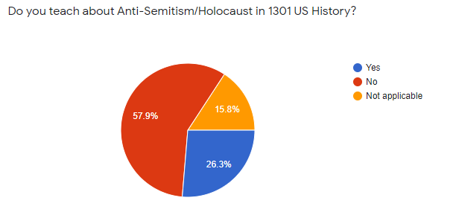
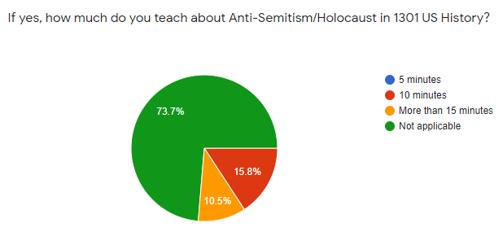
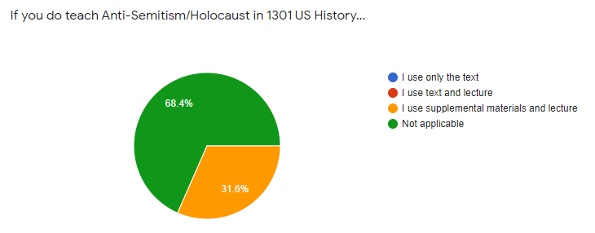
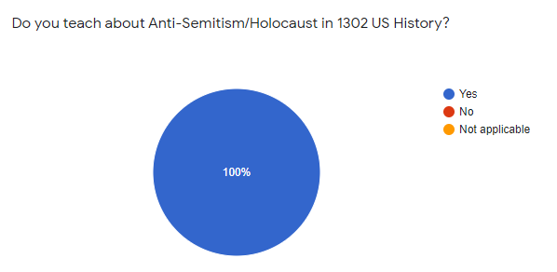
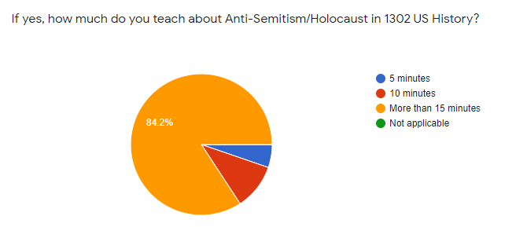
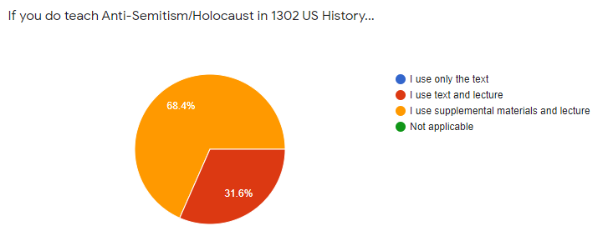

Seminar Literature
Alinsky, Saul. 1989, “Rules for Radicals: A Practical primer for realistic radicals.”

Carmichael, Joel, The Satanizing of the Jews: Origin and Development of Mystical Anti-Semitism

(New York: Fromm Publishing, 1993).

Dawidowicz, Lucy, The War Against the Jews (New York: Holt, Rinehart, and Winston, 1975).
Dinnerstein, Leonard, Antisemitism in America (New York: Oxford University Press, 1994).

Durham, Martin. White Rage (New York: Routledge, 2007).
Gilroy, Paul. Black Atlantic.
Goldstein, Phyllis, A Convenient Hatred: The History of Anti-Semitism (Brookline: Facing
History Ourselves, 2012).

Finkielkraut, Alan. The Imaginary Jew (Lincoln: The University of Nebraska Press, 1994).
Laqueur, Walter, The Changing Face of Antisemitism: From Ancient Times to the Present Day
(Oxford: Oxford University Press, 2006).

Marx, Karl, “On the Jewish Question (Zur Judenfrage)” (1843). Available online at http:
www.marxists.org.archive/marx/works/1844//jewish-question/

Medoff, R. (2017, July). “Biased textbooks turning young Americans against Israel.” Jewish
News Service. http://www.jns.org/latest-articles/2017/7/10/biased-textbooks-turning-young-americans-against-israel-research-shows/. WWevzHXyvGI=

Miller, Arthur, Focus. (New York: Penguin Books, 2001).

Perry, Marvin and Frederick M. Schweitzer, Antisemitism: Myth and Hate from Antiquity to the
Present (New York: Palgrave Macmillan TM, 2000).

Pollack. E. (2011). Antisemitism on the Campus: Past and Present (Antisemitism in America).
Brighton: Academic Studies Press.

Prager, Dennis, Why the Jews? The Reason for Antisemitism (New York: Simon and Schuster,
2003).

Sacks, J. “A New Antisemitism?”
https://cst.org.uk/public/data/file/c/1/A_New_Antisemitism_Chief_Rabbi_Sir_Jonathan_Sacks. pdf U.S. Department of State. (2008).
Short, G. (1993). “Prejudice reduction in schools: The value of inter-racial contact.” British
Journal of Sociology of Education, 14 (2), 159-168.
Small, Charles Asher. Global Antisemitism: A Crisis of Modernity (New York: 2014).
Trachtenberg, Joshua, The Devil, and the Jews: The Medieval Conception of the Jew and its
Relation to Modern Anti-Semitism (Philadelphia: Jewish Publication Society, 2002).

Wessler, S., & Moss, M. (2001). “Hate crimes on campus: The problem and efforts to confront
it.” Hate Crimes Series. Bureau of Justice Assistance monograph.
http://files.eric.ed.gov/fulltext/ED459656.pdf

Whine, Michael, MBE. “The perception, impact, and consequences of hate crime.”
https://cst.org.uk/public/data/file/f/1/CEPOL%20perceptions%20of%20hate%20crime.pd
f
Wiesel, Elie, Night. (Hill and Wang, 2006).

Wistrich, Robert, Antisemitism: The Longest Hatred (New York: Schocken, 1991).

Wistrich, Robert, A Lethal Obsession: Antisemitism from Antiquity to the Global Jihad (New
York: Random House, 2010).

Wistrich, Robert. “Antisemitism and the American College Campus: A Historian Examines a
Persistent Problem,” The Forward, June 29, 2011, http://www.forward.com/articles/139195/

Film:
Denial (2015)
The Gentleman’s Agreement (1947)
The Longest Hatred (1993, Documentary)
Night Will Fall (2014)
Imaginary Witness (2004)
American History X (1998)
American Jihad (2017)
The New KKK: - The United States of America (2016)
White Right: Meeting the Enemy” (2017)
Milk (2008)

